- Introduction

- Abstract

- Clean Energy Subsidies: Instruments and Financing

Governments use clean energy subsidies to make low-carbon electricity cheaper relative to fossil fuels. In practice, these subsidies differ in two ways: the instrument used to support clean energy and the way the support is financed.

The most established instrument is the feed-in tariff (FIT). Under FIT, clean energy producers receive a fixed, guaranteed price for each unit of electricity they sell usually above the market price and for a long contract period. A related instrument is the feed-in premium which pays producers a fixed bonus on top of the market price. Both reduce the income risk of clean energy projects. A second group of instruments works through the tax system. Tax credits lower the tax bill of firms that invest in or produce clean energy: in the United States, the two main examples are the Production Tax Credit which subsidizes each unit of clean electricity generated and the Investment Tax Credit which subsidizes the cost of building clean energy capacity. Tax incentives are the instrument most often used to promote renewable energy investment in developing countries while developed countries rely more on feed-in tariffs, auctions and financial incentives. A third instrument is the auction, also called a tender. In an auction, both the price and the quantity of clean energy are determined through a competitive bidding process before the project starts. This gives producers a stable revenue guarantee like a feed-in tariff while letting the government control how much capacity is built and at what cost; auctions have become increasingly common as the cost of clean energy has fallen. Finally, governments also use direct grants, low-interest loans and consumer-side subsidies such as payments for households that install solar panels which support adaptation rather than large-scale generation.

The instrument determines how the subsidy is delivered but the subsidy must also be paid for by someone. Three financing channels are common. The first is the general government budget where the subsidy is funded out of ordinary tax revenue, like any other public spending. The second is a levy on electricity bills where consumers pay a small additional charge on every unit of electricity and the revenue is used to support clean energy: Germany used this approach for many years through its clean energy additional charges. The third channel is revenue from carbon pricing where income from emissions trading systems or carbon taxes is redirected to fund clean energy support. The choice of financing channel matters because each one has different effects on prices, public budgets and the distribution of costs across households. A subsidy financed by an electricity tax raises the price consumers pay for power while a subsidy financed from the general budget does not.

In the model used in this thesis the clean energy subsidy is a payment that lowers the effective price of clean energy financed by a lump-sum tax. This is a simplification: it captures the price effect of the subsidy while abstracting from the specific instrument and from the distortions of real-world financing. The variety of instruments and financing channels described above is therefore not modelled directly but it is useful for interpreting the results and their limitations.

- Literature Review

- Model

The model features two intermediate-goods sectors that differ in their energy mix: one is dirty-energy-heavy and the other clean-energy-heavy. Their outputs are combined into aggregate final output by a CES aggregator which allows for imperfect substitutability between sectors. Capital and labor can move between sectors but face intersectoral adjustment costs so reallocation is gradual rather than instantaneous. This setup captures how an energy subsidy affects not only energy demand but also the allocation of capital and labor across sectors and through these general-equilibrium linkages, sectoral and aggregate output.

5.1 Households

The economy is populated by a representative household. The household chooses consumption, investment and next-period capital to maximize lifetime utility:

$\max_{\{C_{t},I_{t},K_{t+1}\}_{t=0}^{∞}}{\sum_{t=0}^{∞}{β^{t}}\ln{C_{t}}}$

subject to budget constraint:

$$C_{t}+I_{t}+T_{t}=w_{t}L_{t}+r_{t}K_{t}+Π_{t}$$

and the law of motion for capital:

$$K_{t+1}=\left(1-δ\right)K_{t}+I_{t}$$

The household receives labor income, capital income and firm profits. Labor supply is fixed at $\overline{L}=1$ so the household does not choose labor. This isolates the role of capital accumulation and energy use in the response to clean energy subsidies.

In the equations above $C_{t}$ denotes consumption, $I_{t}$ investment, $K_{t}$ capital, $w_{t}$ the wage, $r_{t}$ the return on capital, $T_{t}$ lump-sum taxes and $Π_{t}$ firm profits. Profits are related to the household since the intermediate-goods sectors earn positive profits under imperfect substitutability. The parameter $β$ is the discount factor and $δ$ is the depreciation rate of capital.

The Euler equation is:

$$\frac{C_{t+1}}{C_{t}}=β\left(1-δ+r_{t+1}\right)$$

The model is solved using perfect foresight simulation over 300 periods tracing the full transition path between two steady states. In steady state consumption and capital are constant so the Euler equation implies:

$$r=\frac{1}{β}-1+δ$$

In steady state capital is constant over time so investment satisfies:

$$I=δK$$

5.2 Final Good Producer

The economy contains a competitive final-good producer that combines the outputs of the two sectoral goods producers into aggregate final output. The final good is used for consumption, investment and as an input in energy production. Aggregate output is produced according to a CES aggregator:

$$Y_{t}={\left(η Y_{1,t}^{\frac{ρ-1}{ρ}}+\left(1-η\right) Y_{2,t}^{\frac{ρ-1}{ρ}}\right)}^{\frac{ρ}{ρ-1}}$$

The parameter $η∈\left(0,1\right)$ is the weight of sector 1 in final-good production, calibrated to $η= 0.5$ so both sectors enter symmetrically. The parameter $ρ> 1$ governs the elasticity of substitution between the two sectoral goods. With $ρ= 5$ the sectors are gross substitutes meaning the economy can shift production between them in response to relative price changes. The final good is the numeraire so its price is normalized to one.

The final good producer solves:

$${\max_{Y_{1,t},Y_{2,t}}\left(η Y_{1,t}^{\frac{ρ-1}{ρ}}+\left(1-η\right) Y_{2,t}^{\frac{ρ-1}{ρ}}\right)}^{\frac{ρ}{ρ-1}}-P_{1,t}Y_{1,t}-P_{2,t}Y_{2,t}$$

The first-order conditions imply the sectoral prices:

$$P_{1,t}=η{\left(\frac{Y_{t}}{Y_{1,t}}\right)}^{1/ρ}$$

$$P_{2,t}=\left(1-η\right){\left(\frac{Y_{t}}{Y_{2,t}}\right)}^{1/ρ}$$

Since the final good is the numeraire, $P_{1,t}$ and $P_{2,t}$ are relative prices: they measure the marginal contribution of each sectoral good to aggregate output.

5.3 Intermediate Goods Sectors

There are two intermediate goods sectors $j∈\{1,2\}$. Each sector produces a differentiated sectoral good using capital, labor, and energy services:

$Y_{j,t}=A_{j}K_{j,t}^{α_{j}}L_{j,t}^{β_{j}}{\left(χ_{t}E_{j,t}\right)}^{1-α_{j}-β_{j}}$

The parameter $χ$ captures energy efficiency in production, calibrated to $χ=1$ in the baseline. Each intermediate goods firm takes the sectoral price $P_{j,t}$ factor prices and the sector-specific energy price index $P_{E,j,t}$ as given. Capital and labor are mobile across sectors but subject to intersectoral adjustment costs. The firm solves:

$$\max_{K_{j,t},L_{j,t},E_{j,t}}\left(P_{j,t}Y_{j,t}-r_{t}K_{j,t}-w_{t}L_{j,t}-P_{E,j,t}E_{j,t}-\frac{ϕ_{K}}{2}{\left(K_{j,t}-K_{j,t-1}\right)}^{2}-\frac{ϕ_{L}}{2}{\left(L_{j,t}-L_{j,t-1}\right)}^{2}\right)$$

The energy share is defined as $γ_{j}=1-α_{j}-β_{j}$. The first-order conditions are:

$$P_{j,t}α_{j}\frac{Y_{j,t}}{K_{j,t}}=r_{t}+ϕ_{K}\left(K_{j,t}-K_{j,t-1}\right)$$

$$P_{j,t}β_{j}\frac{Y_{j,t}}{L_{j,t}}=w_{t}+ϕ_{L}\left(L_{j,t}-L_{j,t-1}\right)$$

$$P_{E,j,t}=P_{j,t}γ_{j}\frac{Y_{j,t}}{E_{j,t}}$$

The adjustment cost terms $ϕ_{K}\left(K_{j,t}-K_{j,t-1}\right)$ and $ϕ_{L}\left(L_{j,t}-L_{j,t-1}\right)$ create a wedge between the marginal product of a factor and its market price during transition. In steady state these terms vanish and the conditions reduce to the standard static FOC. These adjustment costs are a real resource cost borne by the economy, they enter the aggregate resource constraint discussed in Section 3.7.

5.4 Energy Services

Each intermediate goods sector combines fossil and renewable energy into energy services. The resulting energy service $E_{j,t}$ enters the production function of intermediate sector $j:$

$$E_{j,t}={\left[ω_{j}E_{f,j,t}^{\frac{σ-1}{σ}}+\left(1-ω_{j}\right)E_{r,j,t}^{\frac{σ-1}{σ}}\right]}^{\frac{σ}{σ-1}}$$

Energy price index:

$$P_{E,j,t}={\left[ω_{j}^{σ}P_{f,t}^{1-σ}+{\left(1-ω_{j}\right)}^{σ}P_{r,t}^{1-σ}\right]}^{\frac{1}{1-σ}}$$

Demand functions:

$$E_{f,j,t}=ω_{j}^{σ}{\left(\frac{P_{f,t}}{P_{E,j,t}}\right)}^{-σ}E_{j,t}$$

$$E_{r,j,t}={\left(1-ω_{j}\right)}^{σ}{\left(\frac{P_{r,t}}{P_{E,j,t}}\right)}^{-σ}E_{j,t}$$

The parameter $ω_{j}$ is the sector-specific weight of dirty energy in the energy aggregator: a higher $ω_{j}$ means sector j is more dirty-intensive a lower value means greater reliance on clean energy. The parameter $σ$ is the elasticity of substitution between dirty and clean energy, when $σ$ is high firms substitute more easily in response to relative price changes. The energy prices $P_{f,t}$ and $P_{r,t}$ are economy-wide and identical across sectors: the price index $P_{E,j,t}$ differs across sectors only because $ω_{j}$ differs.

5.5 Energy Sector

Energy is produced by transforming the aggregate final goods into energy inputs using linear technologies:

$$E_{f,t}=\frac{z_{f}}{c_{f}}M_{f,t}, E_{r,t}=\frac{z_{r}}{c_{r}}M_{r,t}$$

The parameters $z_{f}$ and $z_{r}$ are the productivity of dirty and clean energy production: $c_{f}$ and $c_{r}$ are the unit input costs measured in units of the final good. The ratios $z_{f}/c_{f}$ and $z_{r}/c_{r}$ determine how efficiently final goods are converted into energy. These technological parameters play a key role in determining equilibrium energy prices.

The variables $M_{f,t}$ and $M_{r,t}$ represent the amount of final goods used as inputs in the production of fossil and renewable energy. They are determined residually from $E_{f,t}$ and $E_{r,t}$ and do not enter any other equilibrium condition directly.

Energy is produced by transforming the aggregate final good into energy inputs using linear technologies. Throughout the subscript $f$ denotes dirty energy and $r$ denotes clean energy:

$$P_{f,t}=\frac{c_{f}}{z_{f}}, P_{r,t}=\frac{c_{r}}{z_{r}}-s_{t}$$

with:

$$0≤s_{t}<\frac{c_{r}}{z_{r}}$$

The subsidy $s_{t}$ is paid by the government to clean energy producers. Firms still receive their marginal cost $c_{r}/z_{r}$ but the price faced by buyers falls to $c_{r}/z_{r}-s_{t}$. The subsidy is financed by the lump-sum tax $T_{t}.$

Market clearing:

$$E_{f,t}=E_{f,1,t}+E_{f,2,t}$$
$$E_{r,t}=E_{r,1,t}+E_{r,2,t}$$

5.6 Government

The government uses renewable energy subsidies as the only policy instrument. The model abstracts from carbon taxation and focuses on the effects of subsidies that reduce the effective price of renewable energy paid by firms. Government spending on renewable energy subsidies is financed through lump-sum taxes. The government budget constraint is:

$$T_{t}=s_{t}E_{r,t}$$

where $T_{t}$ denotes lump-sum taxes, $s_{t}$is the per-unit renewable energy subsidy and $E_{r,t}$ is aggregated renewable energy use.

Since taxes are lump-sum the policy does not directly distort household decisions. The subsidy affects the economy only by changing the relative price of clean energy and through it the energy mix chosen by firms. The model does not include a negative externality from dirty energy such as emissions or climate damage. The subsidy is therefore studied as a pure relative-price intervention: the analysis asks how it reallocates resources and affects output and consumption not whether it corrects a market failure.

5.7 Resource Constraint

Aggregate final output is used for consumption, investment, and as an input in the production of fossil and renewable energy. The economy-wide resource constraint is:

$$Y_{t}=C_{t}+I_{t}+M_{f,t}+M_{r,t}+\frac{ϕ_{K}}{2}\sum_{j=1}^{2}{{\left(K_{j,t}-K_{j,t-1}\right)}^{2}}+\frac{ϕ_{L}}{2}\sum_{j=1}^{2}{{\left(L_{j,t}-L_{j,t-1}\right)}^{2}}$$

Using the linear energy production technologies, this can be written as:

$$Y_{t}=C_{t}+I_{t}+\frac{c_{f}}{z_{f}}E_{f,t}+\frac{c_{r}}{z_{r}}E_{r,t}+\frac{ϕ_{K}}{2}\sum_{j=1}^{2}{{\left(K_{j,t}-K_{j,t-1}\right)}^{2}}+\frac{ϕ_{L}}{2}\sum_{j=1}^{2}{{\left(L_{j,t}-L_{j,t-1}\right)}^{2}}$$

The quadratic terms are the intersectoral adjustment costs introduced in Section 3.3. They represent final output lost when capital and labor are reallocated across sectors and they vanish in steady state. Although the final good serves both as output and as an input into energy production this circularity is resolved in general equilibrium. The resource constraint ensures that the allocation of final output across consumption, investment and energy production is mutually consistent. This specification follows a standard approach in energy-macro models where energy is produced from the aggregate good rather than from a primary resource endowment, see for example Heutel (2012) or Golosov et al. (2014).

The resource constraint highlights that energy production is not costless. Policies that increase renewable energy use therefore affect the allocation of aggregate resources creating a trade-off between the energy transition, investment and consumption.

5.8 Factor Market Clearing

Aggregate capital and labor are allocated across the two intermediate goods sectors. Factor markets clear according to:

$$K_{t}=K_{1,t}+K_{2,t}$$
$$L_{t}=L_{1,t}+L_{2,t}$$

Total labor supply is normalized to:

$$L_{t}=\overline{L}$$

These conditions ensure that the total amount of capital and labor used by the two intermediate goods sectors equals the aggregate supply of each factor. Capital and labor are mobile across sectors but reallocation is subject to the adjustment costs introduced in Section 3.3. Factor returns are therefore equalized across sectors only in steady state: during the transition they differ by the adjustment cost wedge.

5.9 Steady State

The numerical analysis studies the transition between two steady states. This section characterizes the steady state itself: the transition path is analyzed in the next chapter. In steady state all endogenous variables are constant over time and the policy parameter is fixed. Therefore:

$$C_{t}=C, K_{t}=K, I_{t}=I, Y_{t}=Y$$
$$Y_{j,t}=Y_{j}, K_{j,t}=K_{j}, L_{j,t}=L_{j}, E_{j,t}=E_{j}$$
$$E_{f,j,t}=E_{f,j}, E_{r,j,t}=E_{r,j}, E_{f,t}=E_{f}, E_{r,t}=E_{r}$$

Prices are also constant:

$$w_{t}=w, r_{t}=r, P_{1,t}=P_{1}, P_{2,t}=P_{2}$$
$$P_{f,t}=P_{f}, P_{r,t}=P_{r}, P_{E,j,t}=P_{E,j}$$

The household Euler equation implies the steady-state return on capital:

$$r=\frac{1}{β}-1+δ$$

Capital accumulation implies:

$$I = δK$$

The steady-state resource constraint is:

$$Y=C+δK+\frac{c_{f}}{z_{f}}E_{f}+\frac{c_{r}}{z_{r}}E_{r}.$$

These conditions provide the basis for the numerical analysis in the next section.

5.10 Economic Mechanism

A higher clean energy subsidy lowers the effective price of clean energy. This reduces the sector-specific energy price index especially in clean-energy-heavy sectors. Firms then adjust their energy mix, input demand and production decisions.

Because the two intermediate-goods sectors differ in their energy composition the effect of the subsidy is asymmetric across sectors. The clean-oriented sector benefits more from the decline in clean energy prices while the dirty-oriented sector is affected less strongly. These sectoral responses change $Y₁$ and $Y₂$ and through the CES final-good aggregator introduced in Section 3.2 they affect aggregate output Y.

The model therefore captures general-equilibrium linkages from clean energy policy to sectoral production, factor allocation, aggregate output and consumption.

5.11 Equilibrium Conditions

A competitive equilibrium in this economy is defined as a sequence of quantities and prices such that households and firms optimize, the government budget constraint holds and all markets clear.

More precisely, an equilibrium consists of quantities:
$$\{C_{t},I_{t},K_{t},L_{t},K_{1,t},K_{2,t},L_{1,t},L_{2,t},Y_{t},Y_{1,t},Y_{2,t},E_{j,t},E_{f,j,t},E_{r,j,t},E_{f,t},E_{r,t}\}_{t=0}^{∞} , j∈\{1,2\}$$

and prices:

$$\{w_{t},r_{t},P_{1,t},P_{2,t},P_{f,t},P_{r,t},P_{E,j,t}\}_{t=0}^{∞}, j∈\{1,2\}$$

such that the following conditions are satisfied.

First, the representative household maximizes lifetime utility subject to its budget constraint and the law of motion for capital. Second, the final-good producer combines the two sectoral goods into aggregate output and sets sectoral prices equal to their marginal contributions to final output. Third, intermediate goods firms maximize profits by choosing capital, labor and energy services. Fourth, each intermediate goods sector combines fossil and renewable energy into energy services through the CES aggregator. Fifth the government balances its budget: subsidy spending equals lump-sum tax revenue.

The energy sector operates under perfect competition, so fossil and renewable energy prices are given by:

$$P_{f,t}=\frac{c_{f}}{z_{f}},$$
$$P_{r,t}=\frac{c_{r}}{z_{r}}-s_{t}.$$

The government budget constraint is:

$T_{t}=s_{t}E_{r,t}$

The aggregate resource constraint is:

$$Y_{t}=C_{t}+I_{t}+\frac{c_{f}}{z_{f}}E_{f,t}+\frac{c_{r}}{z_{r}}E_{r,t}+\frac{ϕ_{K}}{2}\sum_{j=1}^{2}{{\left(K_{j,t}-K_{j,t-1}\right)}^{2}}+\frac{ϕ_{L}}{2}\sum_{j=1}^{2}{{\left(L_{j,t}-L_{j,t-1}\right)}^{2}}$$

Capital and labor markets clear:

$$K_{t}=K_{1,t}+K_{2,t}$$
$$L_{t}=L_{1,t}+L_{2,t}$$

Fossil and renewable energy markets clear:

$$E_{f,t}=E_{f,1,t}+E_{f,2,t}$$
$$E_{r,t}=E_{r,1,t}+E_{r,2,t}$$

Together these conditions determine equilibrium production, factor allocation, energy use, prices and consumption. The model is then solved numerically as a perfect-foresight transition between the steady states with and without the clean energy subsid

6. Numerical Analysis

This section presents the quantitative results of the model. The model is solved in Julia using Dynare under perfect foresight. The baseline experiment introduces a permanent renewable energy subsidy of $s=0.20$ starting from a no-subsidy steady state, $s=0$.

The analysis has three parts. First it compares the initial and terminal steady states to identify the long-run effects of the policy. Second it studies the transition dynamics of consumption, output, capital, investment and energy demand. Third it uses decomposition experiments to separate the main mechanisms behind the results: the energy channel, the capital channel and the role of sectoral heterogeneity.

6.1 Calibration and Parameter Choice

The model is calibrated as a benchmark economy rather than as a precise empirical fit to one country. The aim of the calibration is to keep the model simple while preserving the main economic mechanism: a clean energy subsidy changes relative energy prices, affects the energy mix and reallocates production across sectors.

The model period is one year. Standard macroeconomic parameters are used for the household and production side of the model. The discount factor is set to $β=0.96$ and the depreciation rate is set to $δ=0.08$. These values imply a steady-state return on productive capital of:

$$r=\frac{1}{β}-1+δ=0.122.$$
This return should be interpreted as the model-implied return on productive capital not as a risk-free interest rate.

Production shares are symmetric across the two sectors. The capital share is set to $α_{i}=0.33$, and the labor share is set to $β_{i}=0.61$. The energy share is then calculated residually as:

$$γ_{i}=1-α_{i}-β_{i}=0.06.$$
The two sectors differ only in their energy mix. Sector 1 is dirty-energy intensive while sector 2 is clean-energy intensive. This assumption isolates the main mechanism of the model: the subsidy affects sectors differently because they rely on different energy inputs.

Table 1 summarizes the calibrated parameters, their values and the justification for each choice
Parameter | Value | How chosen / calculated | Source / justification
$$β$$ | 0.96 | Standard annual discount factor | Standard RBC calibration/Kydland & Prescott (1982)
$$δ$$ | 0.08 | Annual depreciation rate | Standard macro calibration/Kydland & Prescott (1982)
$$r$$ | 0.122 | r=1/β−1+δ | Implied by Euler equation
$$α_{i}$$ | 0.33 | Capital share in Cobb-Douglas production | Standard macro/RBC calibration/Kydland & Prescott (1982)
$$β_{i}$$ | 0.61 | Labor share chosen so that energy share is small | Calibration target
$$γ_{i}$$ | 0.06 | $$1-α_{i}-β_{i}$$ | Close to energy expenditure share/Golosov, Hassler, Krusell & Tsyvinski (2014)/ Matches U.S. energy expenditure share of GDP (~5–6%, EIA)
$$σ$$ | 2.0 | Elasticity between fossil and renewable energy | Benchmark value/Papageorgiou, Saam & Schulte (2017)
$$ρ$$ | 5.0 | Elasticity between sectoral goods | Gross substitutes assumption/Atkeson & Kehoe
$$η$$ | 0.50 | Symmetric final-good weight | Normalization
$$ω_{1}$$ | 0.85 | Sector 1 dirty-heavy | Model assumption
$$ω_{2}$$ | 0.15 | Sector 2 renewable-heavy | Model assumption
$$c_{f}$$ | 1.00 | Fossil energy cost normalized | Normalization
$$c_{r}$$ | 1.05 | Renewable energy slightly more costly before subsidy | Calibration assumption
$$Φ_{K}$$ | 0.5 | Capital adjustment cost | Benchmark transition parameter/Hayashi (1982)
$$Φ_{L}$$ | 0.2 | Labor adjustment cost | Benchmark transition parameter/Hayashi (1982)
$$A_{i},χ,z_{f},z_{r},\overline{L}$$ | 1.0 | Scale normalizations | Do not affect relative dynamics

6.2 Numerical Implementation

The model is solved in Julia using Dynare. The simulation is run under perfect foresight: the subsidy is unanticipated before t = 1 but once it is introduced agents know that it is permanent and adjust accordingly.

The policy experiment is a permanent increase in the subsidy from $s = 0$ to $s = 0.20$. The solution proceeds in three steps. First the model computes the initial steady state with no subsidy. Second, it computes the terminal steady state with the subsidy in place. Third it solves for the transition path linking the two steady states.

The transition is simulated over 300 periods to ensure full convergence. The figures below report the first 60 periods where most of the adjustment takes place.

6.3 Steady-State Comparison

Before turning to the transition dynamics I compare the initial steady state with $s=0$ and the terminal steady state with $s=0.20$.

The subsidy lowers the effective clean energy price from $P_{r}=1.05$ to $P_{r}=0.85$. This mainly affects the clean-heavy sector. Its energy price index falls from $P_{E_{2}}=1.41$to $P_{E_{2}}=1.15$ while the dirty-heavy sectors energy price index remains almost unchanged moving from $P_{E_{1}}=1.34$to $P_{E_{1}}=1.34$. This asymmetry is the main source of sectoral reallocation.

In the terminal steady state clean energy share rises from 48.4% to 55.4% an increase of 7 percentage points. Output also shifts across sectors. Output in the dirty-heavy sector falls while output in the clean-heavy sector rises. Aggregate output increases by about 1.1%.

Capital and labor also move toward the clean-heavy sector. $K_{2}$ rises by 3.5% and $L_{2}$ rises by 2.4% while $K_{1}$and $L_{1}$fall. Since aggregate labor is fixed the labor response is only a compositional shift. Aggregate capital rises by about 1.1% while long-run consumption changes only slightly by around 0.04%.

Overall the steady-state comparison shows that the subsidy mainly works through relative prices. It lowers the cost of clean energy benefits the clean-heavy sector reallocates factors toward that sector and increases the clean energy share and aggregate output.

6.4 Transition Dynamics

This section shows how the economy moves from the initial steady state to the new steady state after the subsidy shock. The figures report the first 60 periods of the transition.

Figure 1 shows the response of household consumption. Consumption falls immediately after the subsidy is introduced. This short-run decline reflects the cost of the transition: the economy reallocates resources and increases investment so part of output is not used for current consumption. After the initial drop consumption gradually recovers and converges to a slightly higher long-run level.

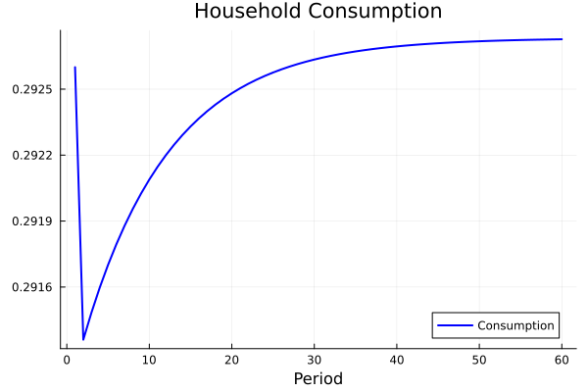
Figure 1. Household consumption after the subsidy shock.

Figure 2 shows aggregate output. Output rises on impact and then slowly converges to the new steady state. Cheaper clean energy lowers production costs in the clean-heavy sector and shifts production toward it.

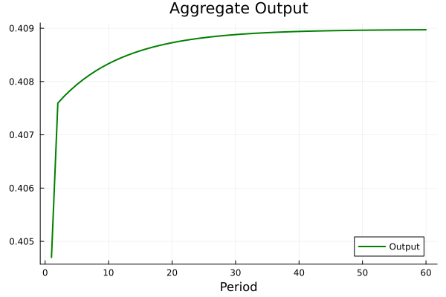
Figure 2. Aggregate output after the subsidy shock.

Figure 3 shows aggregate capital. Capital rises gradually during the transition. The increase is not immediate because capital accumulation takes time and is slowed by adjustment costs. This gradual capital build-up is what supports the long-run increase in output.

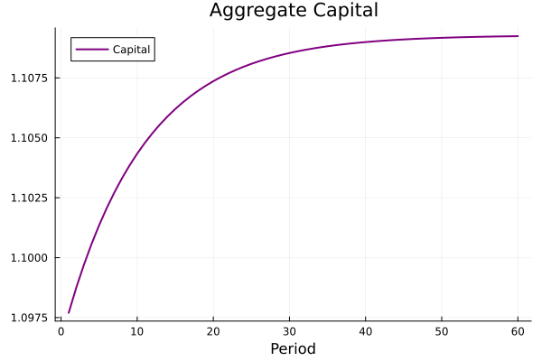
Figure 3. Aggregate capital after the subsidy shock.

Figure 4 shows investment. Investment rises at the beginning of the transition and then slowly declines toward its new steady-state value. This explains why consumption falls in the short run: more resources are temporarily used for investment instead of consumption.

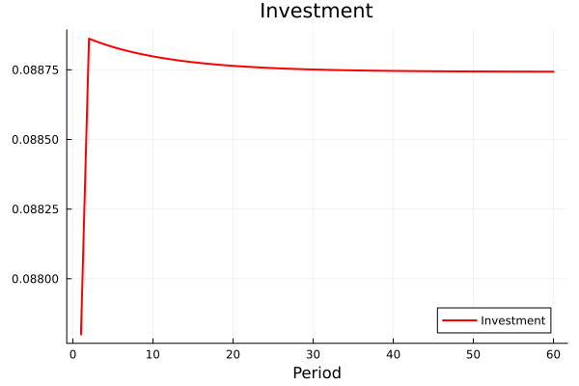
Figure 4. Investment after the subsidy shock.

Figure 5 shows energy demand. Renewable energy use rises after the subsidy, while fossil energy use falls slightly. This confirms the main mechanism of the model: the subsidy changes relative energy prices and shifts the energy mix toward renewable energy.

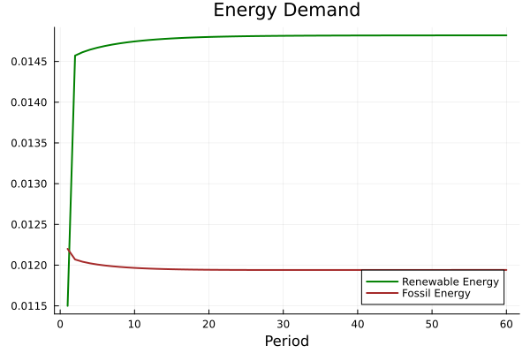
Figure 5. Fossil and renewable energy demand after the subsidy shock.

Overall the transition dynamics show a clear trade-off. The subsidy improves the energy mix and increases output and capital in the long run but it creates a short-run consumption cost during the adjustment process.

6.5 Experiments

The baseline transition shows that the subsidy raises output, capital, clean energy share but it also creates a short-run fall in consumption. This section uses three experiments to identify the mechanisms behind these results.

The first experiment decomposes the short-run consumption drop. The second separates the long-run effect into an energy channel and a capital channel. The third studies how the results depend on the degree of sectoral heterogeneity.

6.5.1 Consumption-Drop Decomposition

Figure 6 compares the consumption response in three cases: the full model, model without adjustment costs and model with frozen capital.

In the full model, consumption falls immediately after the subsidy shock and then gradually recovers. The transition is costly in the short run: the economy reallocates factors and increases investment so fewer resources are available for current consumption.

The model without adjustment costs has a deeper initial fall but recovers faster. Adjustment costs slow down reallocation but they also smooth the transition. Without them economy adjusts more sharply.

The frozen-capital case isolates the energy channel. Here consumption falls only slightly and stays almost flat. This shows that most of the short-run consumption drop comes from capital accumulation and reallocation, not from the change in the energy mix.

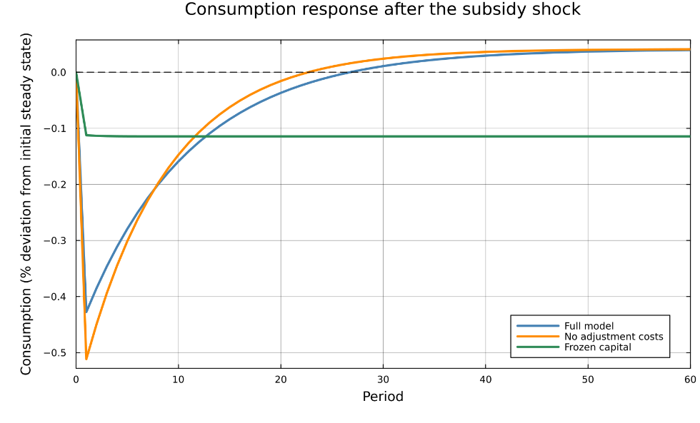
Figure 6. Consumption-drop decomposition.

Overall Figure 6 shows that the short-run consumption cost is mainly driven by the capital channel. The energy channel changes relative prices and the energy mix but the stronger consumption response appears when the economy adjusts capital and investment.

6.5.2 Long-Run Decomposition: Energy and Capital Channels

Figure 7 decomposes the long-run effects of the subsidy into two main channels: the energy channel and the capital channel.

The energy channel captures the direct effect of the subsidy on the energy mix. By lowering the effective price of renewable energy the policy increases renewable energy demand and raises the renewable energy share. This effect is present even when capital is fixed.

The capital channel captures the additional effect coming from capital accumulation and sectoral reallocation. In the full model capital can move and aggregate capital can increase. This strengthens the output response because the economy can expand production in the renewable-heavy sector.

The comparison shows that the increase in the renewable energy share is mainly driven by the energy channel. In contrast, the increase in aggregate output depends more strongly on the capital channel. Without capital adjustment the subsidy still changes the energy mix but output gain is much smaller.
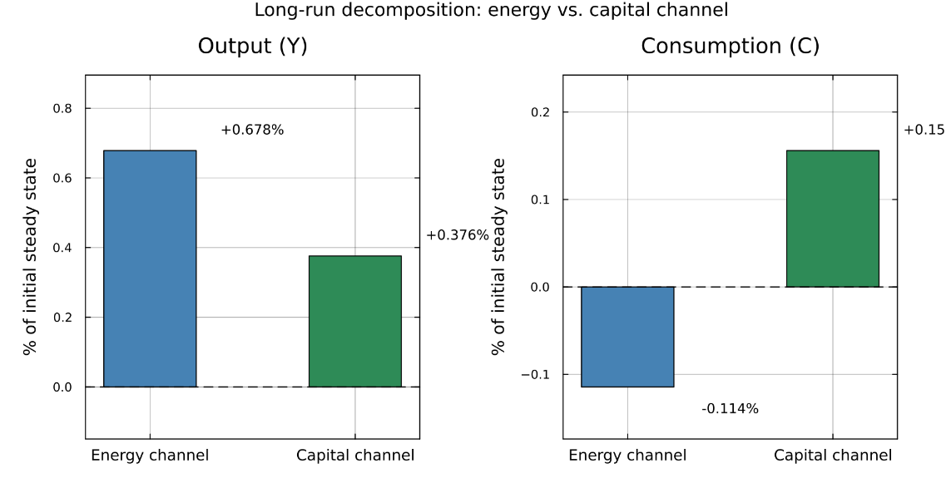
Figure 7. Long-run decomposition: energy and capital channels.

Overall, Figure 7 shows that the subsidy works through two different mechanisms. The energy channel drives the improvement in the energy mix but on its own it slightly reduces consumption. The long-run gains in output and consumption depend mainly on the capital channel.

6.5.3 Sectoral Heterogeneity

Figure 8 shows how the results change when the two sectors become more different. This difference is measured by the gap between $ω_{1}$ and $ω_{2}$. A larger gap means that sector 1 is more dirty-heavy and sector 2 is more clean-heavy.

The left panel shows that heterogeneity matters for sectoral reallocation. When the two sectors are more different, the subsidy creates stronger capital reallocation toward the clean-heavy sector. The fall in the effective clean energy price benefits sector 2 more than sector 1 so capital moves more strongly between the sectors.

The right panel shows the opposite pattern for the clean energy share: the shift in the energy mix is largest when the sectors are similar and falls as heterogeneity rises. When both sectors have a balanced energy mix, each sector has more room to substitute between clean and dirty energy within itself so the aggregate clean share moves more. When the sectors are very specialized there is less room for substitution within each sector and the adjustment works more through reallocation between sectors than through the energy mix.
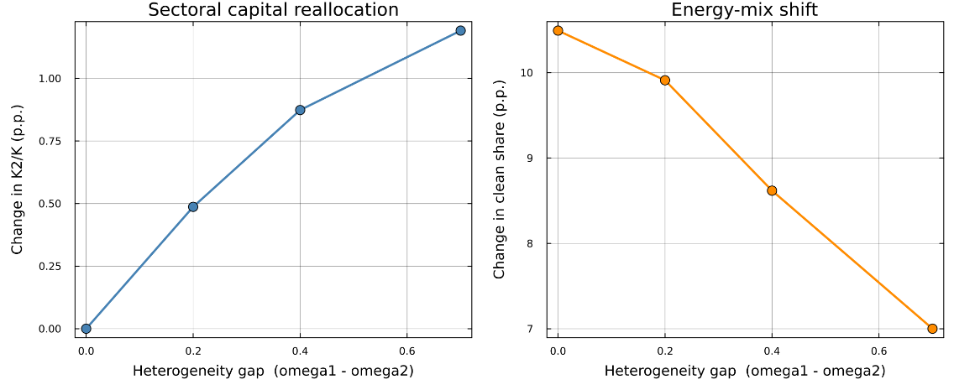
Figure 8. Sectoral heterogeneity and policy effects.

Overall Figure 8 shows that the impact of the subsidy is not only determined by the size of the subsidy itself. It also depends on the initial structure of the economy. The same policy has stronger effects when sectors differ more in their energy composition.

6.6 Economic Mechanism and Interpretation

The results show that the clean energy subsidy works mainly through relative prices. The subsidy lowers the effective price of clean energy. Firms respond by using more clean energy and less dirty energy so the clean energy share rises in the long run.

The policy also changes relative production costs across sectors. Sector 2 uses clean energy more intensively so it benefits more from the subsidy while sector 1 is more dirty-energy intensive and benefits less. This creates a reallocation of production, capital, labor toward sector 2.

The model therefore shows two effects at the same time. First there is an energy-mix effect: the economy uses more clean energy within each sector. Second is that there is a sectoral reallocation effect: production moves toward the sector that benefits more from cheaper clean energy.

The experiments show that these two effects play different roles. The energy-mix effect explains the environmental result which is that the higher clean energy share but on its own it slightly lowers consumption because more final goods are used to produce the more expensive clean energy. The long-run gains in output and consumption come mainly from the capital channel: as capital accumulates and reallocates economy produces more and can afford slightly higher consumption. Without capital adjustment the subsidy still changes the energy mix but the gains in output and consumption are much smaller.

The long-run output effect is positive but it comes with a short-run consumption cost. After the subsidy shock, investment rises and resources are used for adjustment, so consumption initially falls before gradually recovering.

The main conclusion is that a clean energy subsidy can improve the energy mix and raise long-run output, but the transition is not costless. The policy creates short-run adjustment costs, mainly through investment and capital reallocation. Its overall effect depends not only on energy substitution but also on how easily the economy can reallocate factors across sectors.

6.7 Limitations

The model has several limitations. First it is a stylized benchmark model, not an empirical model estimated for a specific country. The calibration is chosen to illustrate the main mechanism, so the quantitative results should not be interpreted as precise policy forecasts.

Second the model includes only two sectors. This keeps the mechanism clear but it abstracts from a richer production structure with many industries, different technologies, and different degrees of energy intensity.

Third, the subsidy is financed by lump-sum taxes. This assumption keeps the focus on the energy and reallocation channels, but it ignores the distortionary effects of real-world public finance. In practice, subsidies must be financed through taxes, debt or spending cuts which may change the welfare effects.

Fourth, the model does not include emissions, environmental damages or climate benefits directly. The clean energy share is used as the main environmental indicator. The model can therefore show how the subsidy changes the energy mix but it cannot measure the full welfare gain from lower emissions.

Finally the model assumes perfect foresight. Agents immediately understand that the subsidy is permanent. In reality, policy uncertainty may slow down investment and factor reallocation.

Overall, these limitations mean that the model should be interpreted as a mechanism exercise. It shows how a clean energy subsidy affects energy use, sectoral allocation and macroeconomic variables but it does not provide a complete cost-benefit analysis of climate policy.

6.8 Summary

This chapter presented the quantitative results of the model. A permanent clean energy subsidy was introduced, and the economy was solved under perfect foresight from the initial to the terminal steady state.

The steady-state comparison showed that the subsidy lowers the effective price of clean energy, raises the clean energy share from 48.4% to 55.4%, and increases aggregate output by about 1.1%. Capital and labor reallocate toward the clean-heavy sector.

The transition dynamics showed that these long-run gains come with a short-run cost. Consumption falls on impact and recovers only gradually, because investment rises during the adjustment.

The three experiments identified the mechanisms behind these results. The short-run consumption drop is driven mainly by the capital channel, not by the change in the energy mix. In the long run, the energy channel explains the higher clean energy share but slightly reduces consumption, while the capital channel drives the gains in output and consumption. Finally, the strength of the policy depends on sectoral heterogeneity: more different sectors lead to stronger reallocation but a smaller shift in the energy mix.

Overall, the analysis shows that a clean energy subsidy can improve the energy mix and raise long-run output, but its effects depend on the economy's ability to reallocate factors across sectors and involve a short-run consumption cost.

7. Conclusion

EIA, Renewable Energy — Incentives
UNCTAD (2023), Investment Policies for the Energy Transition
IRENA, Renewable Energy Auctions: A Guide to Design
Clean Energy Wire (2022), Germany stops landmark mechanism that funded renewables expansion via power bills.

